

**Faculty of Engineering & Technology**

**Electrical & Computer Engineering Department**

**COMMUNICATIONS LAB**

**ENEE4113**

**Experiment No. 2**

**Double-side and Single-side Band Modulation**

**PreLab-2**

**Prepared by:** Ansam Hababeh 1201127

**Instructor**: Dr. Qadri mayyala

**TA**: Eng Hazem Awaysah

**Section**: 3

Contents

Block Simulation (MATLAB Simulink) 1

➢ The full simulation block diagram of the modulation of the DSBSC 2

➢ The full simulation block diagram of the Demodulation of the DSBSC 4

➢ SSBSC Modulation method 1(Lower Side): 6

➢ Demodulation of SSBSC for method 1(Lower side) 7

➢ Single Side Band Modulation Method 2(Lower Side) 9

➢ Single Side Band Demodulation Method 2(Lower Side) 11

➢ All block diagram : 12

List Of Figures:

[Figure 1: Message signal parameters ............................................................................................. 1](https://studentbirzeit-my.sharepoint.com/personal/1200430_student_birzeit_edu/Documents/Desktop/SummerSemester/Lab%20com/myPrelabs/exp2/pre2Exp2.docx#_Toc142259309)

Figure 2:Carrier signal parameters ................................................................................................. 1

Figure 3 : DSBSC Block diagram modulation .................................................................................. 2

Figure 4: Simulation of m(t),c(t) and s(t) ........................................................................................ 2

Figure 5: Spectrum of m(t) ............................................................................................................. 3

Figure 6 : spectrum of c(t) .............................................................................................................. 3

Figure 7 : Spectrum of s(t) .............................................................................................................. 4

Figure 8 : Demodulation of DSBSC ................................................................................................. 4

Figure 9:Demodulation in time domain ......................................................................................... 5

Figure 10: Spectrum of demodulation of DSBSC ............................................................................ 5

Figure 11: SSBSC block diagram ..................................................................................................... 6

Figure 12: Filter2 parameters ......................................................................................................... 6

Figure 13: Modulation of SSBSC in time domain ............................................................................ 7

Figure 14: SSBSC in freq-Domain .................................................................................................... 7

Figure 15: Demodulation Block of SSBSC ....................................................................................... 8

Figure 16:Demodulation SSBSC in frequency domain .................................................................... 8

Figure 17: Modulation Method2 of SSBSC ..................................................................................... 9

Figure 18: Modulated signal in time domain of method 2 ........................................................... 10

Figure 19: modulated signal in frequency domain of SSBC method2 .......................................... 10

Figure 20: SSBSC Demodulation Method 2(Lower Side) Block ..................................................... 11

Figure 21: Time domain demodulation of SSBSC method 2 ......................................................... 11

Figure 22:Frequency domain demodulation of SSBSC method 2 ................................................. 12

Figure 23:All block diagram .......................................................................................................... 12



SOFTWARE PRELAB (MAT

LAB/ PYTHON/ LABVIEW

)

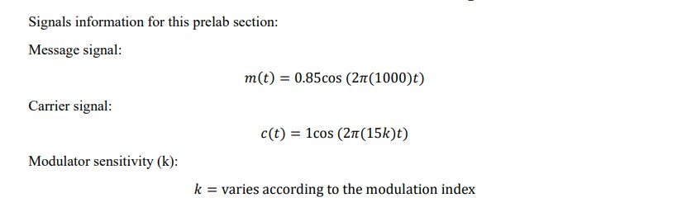

# Block Simulation (MATLAB Simulink)

Parameters for each of message and carrier are:

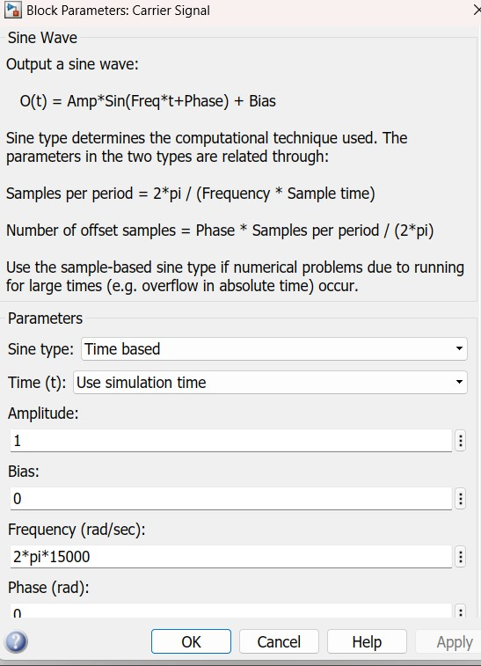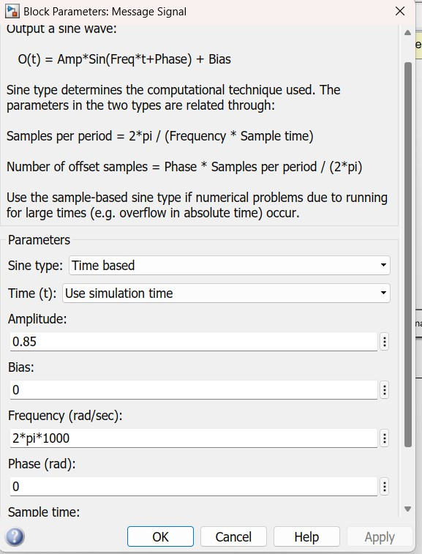

*Figure 1: Message signal parameters Figure 2:Carrier signal parameters*

# ➢ The full simulation block diagram of the modulation of the DSBSC

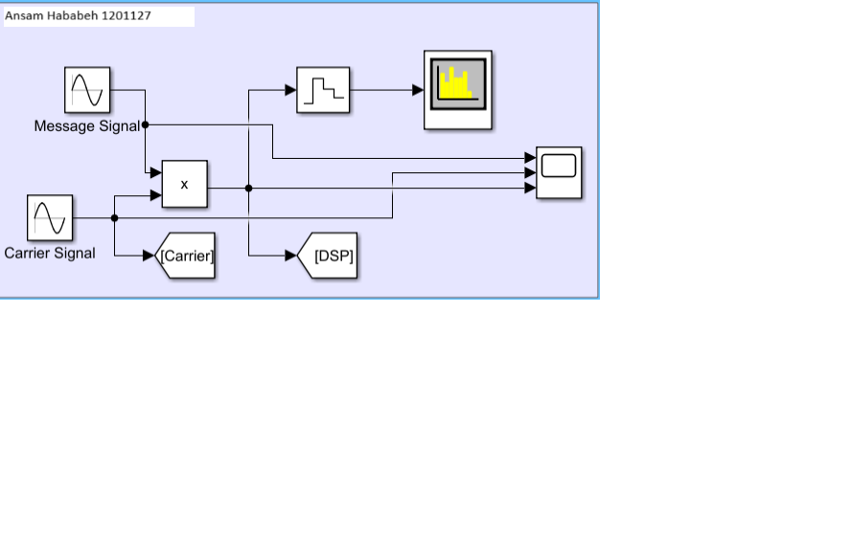

*Figure 3 : DSBSC Block diagram modulation*

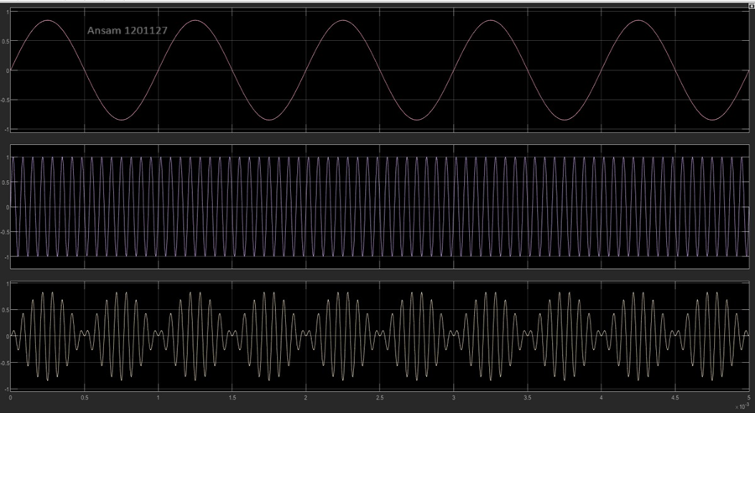

*Figure 4: Simulation of m(t),c(t) and s(t)*

* Modulation in frequency domain :
* Spectrum of m(t) = 0.85 cos(2*п *1000t)
  1. 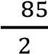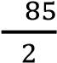0.

m(f)= δ(f − 1000)+ δ(f + 1000)

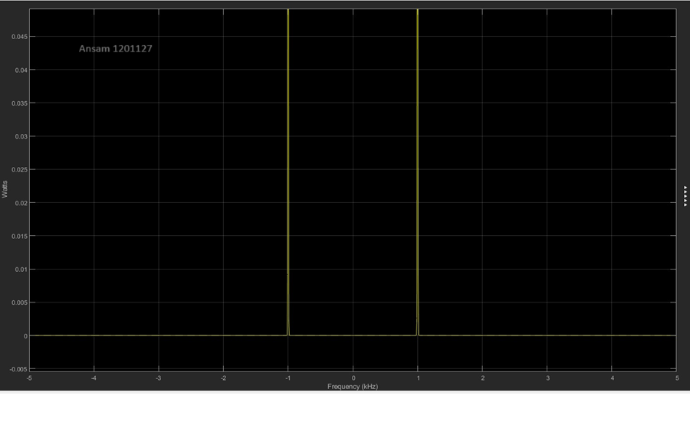

*Figure 5: Spectrum of m(t)*

* Spectrum of c(t) = cos(2*п *15000)

m(f)=  δ(f − 15000)+  δ(f + 15000)

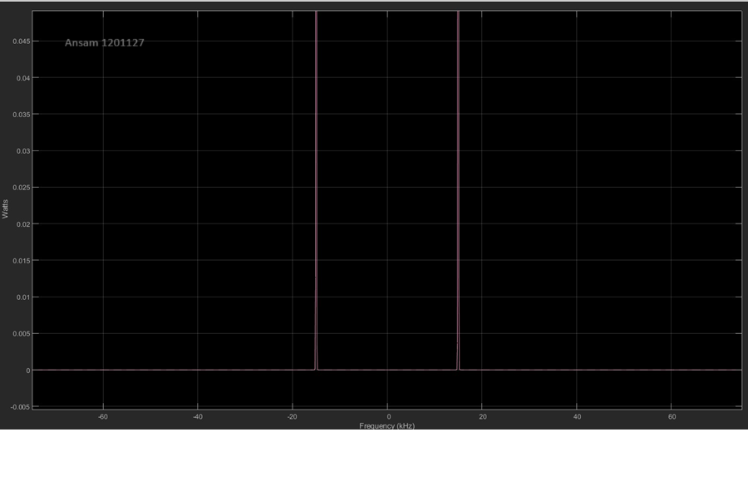

*Figure 6 : spectrum of c(t)*

* spectrum for modulated signal s(t)

S(t) = m(t) c(t)

S(t) = 0.85 cos (2pi (1000) t) * cos (2 pi (15k) t)

* 1. 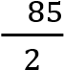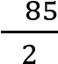0.

S(t) = () cos ( 2pi (16000)) + () cos ( 2pi (14000)) the spectrum will be

at f = 14k and f = 16 k (fc +fm) and(fc-fm)

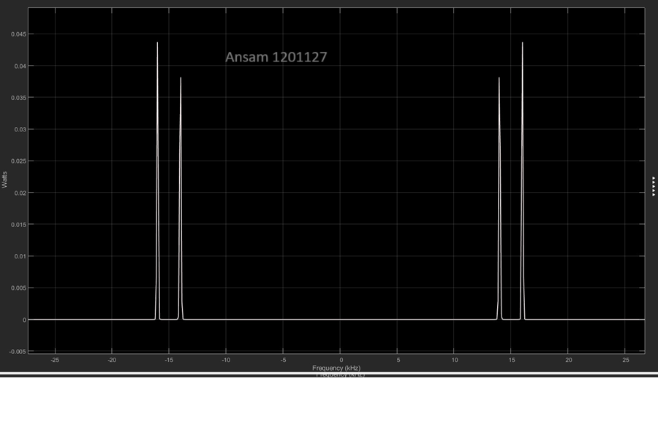

*Figure 7 : Spectrum of s(t)*

# ➢ The full simulation block diagram of the Demodulation of the DSBSC

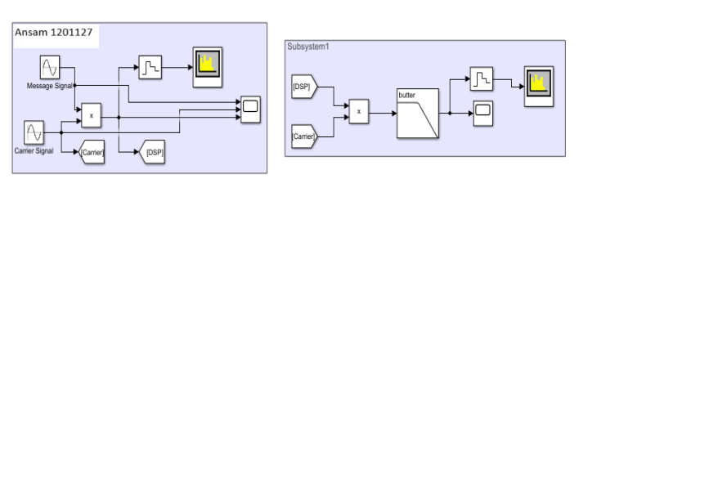

*Figure 8 : Demodulation of DSBSC*

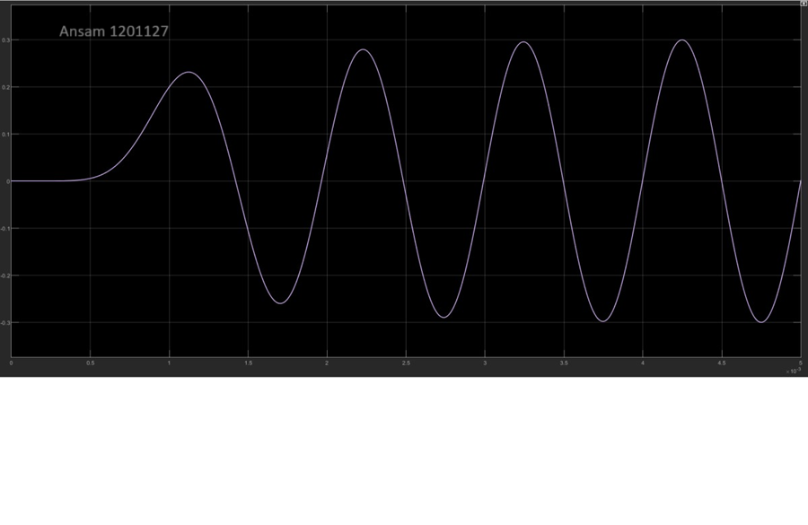

*Figure 9:Demodulation in time domain*

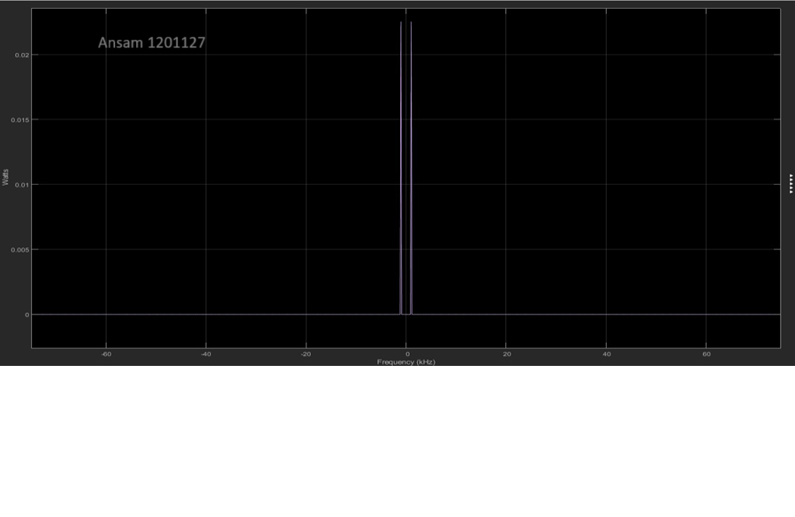

*Figure 10: Spectrum of demodulation of DSBSC*

As we can see the filter returned the exact frequency of message signal at frequency =

1khz.but the amplitude is not correct because there was noise and the filter is not ideal .

o Parameters of Low pass filter :

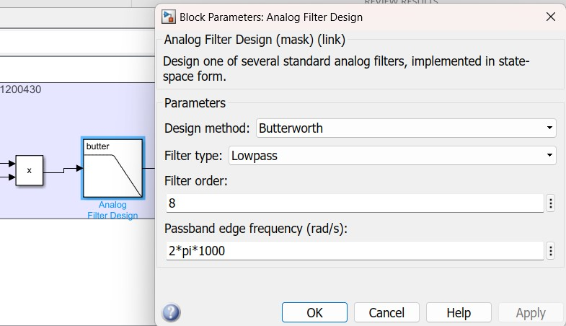

# ➢ SSBSC Modulation method 1(Lower Side):

The SSB modulated signal is represented in the time domain as:

𝐴𝑐 𝑚(𝑡) cos(2𝜋𝑓𝑐𝑡) − 𝐴𝑐 m̂ 𝑠𝑖𝑛(2𝜋𝑓𝑐𝑡).

Where m̂ is the Hilbert transform of m(t ) and is obtained by passing m(t) through a 90° phase shifter

The block diagram of SSBSC :

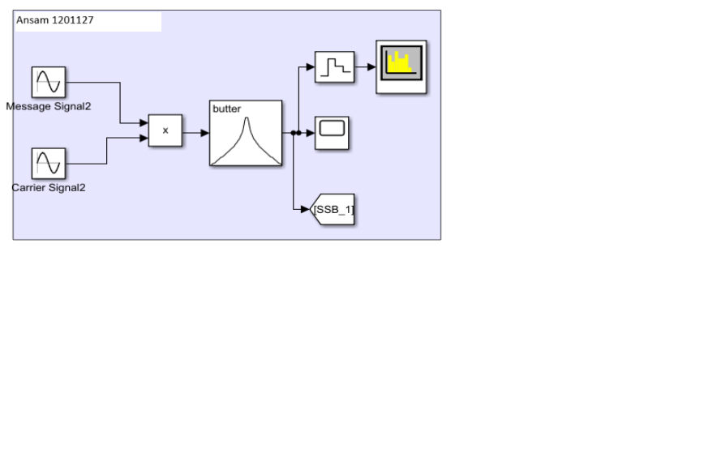

*Figure 11: SSBSC block diagram* Bandpass Filter parameters to return the upper side :

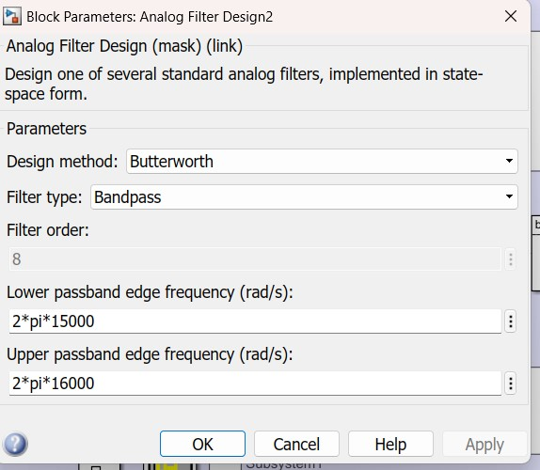

*Figure 12: Filter2 parameters*

Modulation of SSBSC in time domain:

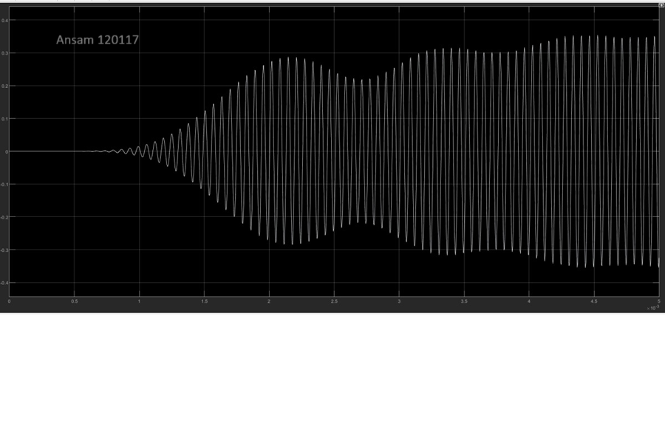

*Figure 13: Modulation of SSBSC in time domain*

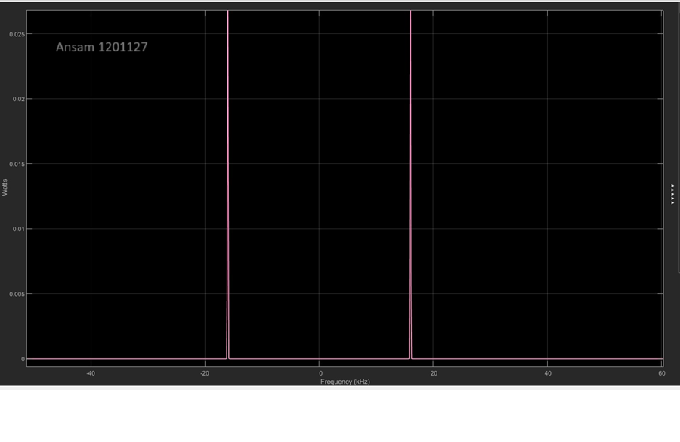

*Figure 14: SSBSC in freq-Domain*

➢ The upper side at f = 16KHz

# ➢ Demodulation of SSBSC for method 1(Lower side)

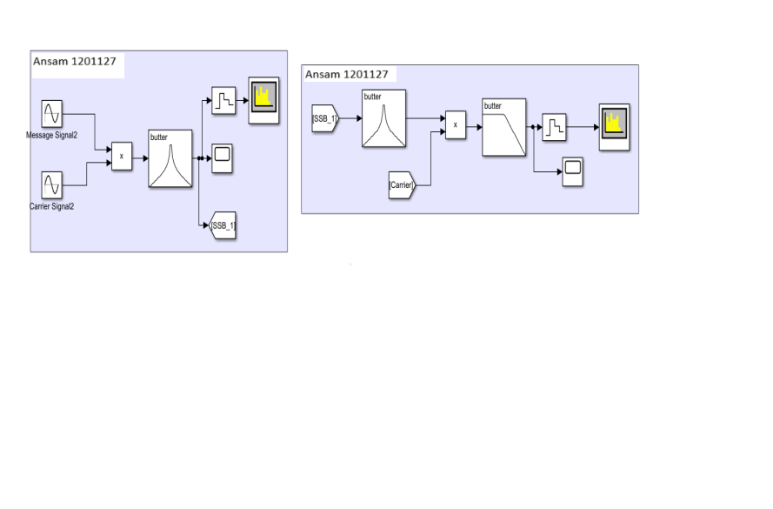

*Figure 15: Demodulation Block of SSBSC* Result in frequency domain of demodulation SSBSC :

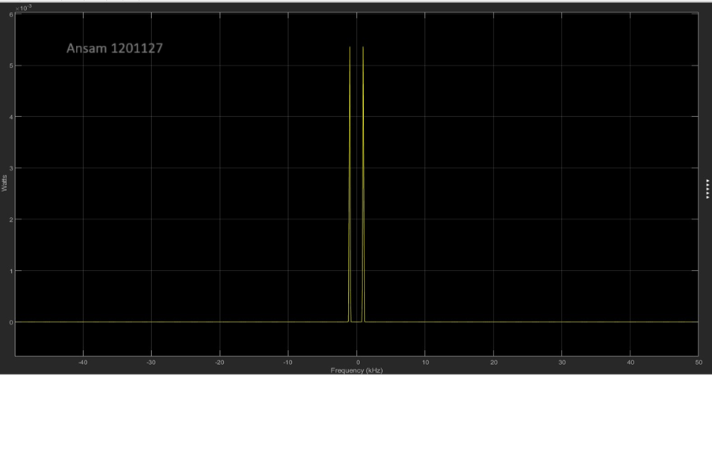

*Figure 16:Demodulation SSBSC in frequency domain*

Result in time domain in 5 cycles:

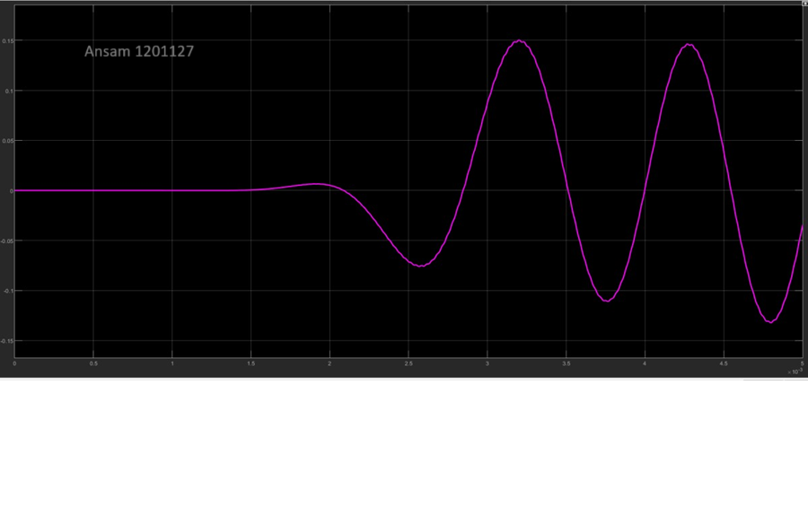

We can see that the frequency of the message signal was returned after demodulation of SSBSC at 1KHZ.

# ➢ Single Side Band Modulation Method 2(Lower Side)

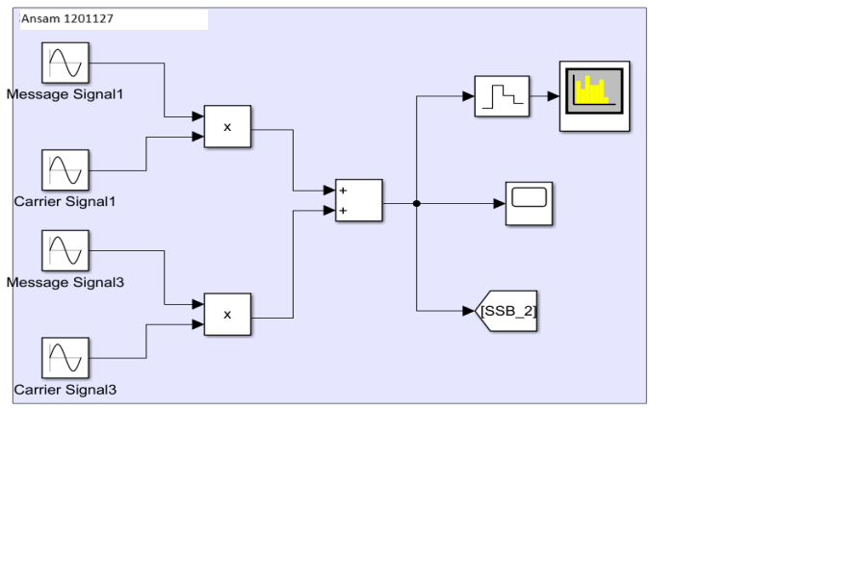

*Figure 17: Modulation Method2 of SSBSC*

Modulated signal in time domain:

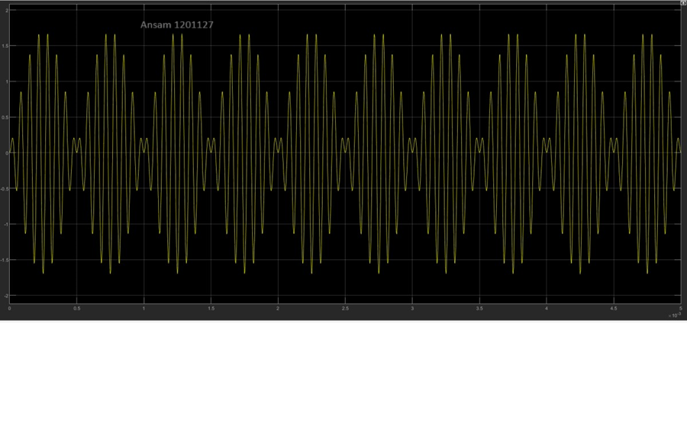

*Figure 18: Modulated signal in time domain of method 2*

And the modulated signal in frequency domain :

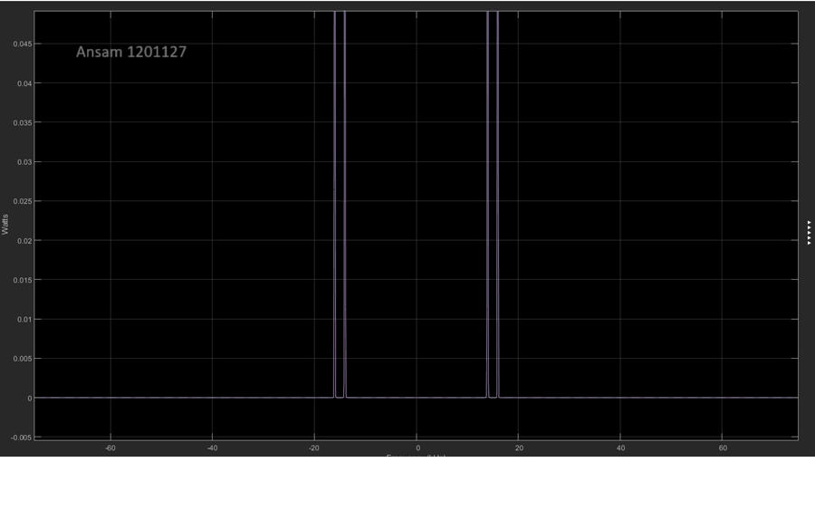

*Figure 19: modulated signal in frequency domain of SSBC method2*

We see that modulated signal of SSBSC give the upper /lower frequency (fc+fm)

# ➢ Single Side Band Demodulation Method 2(Lower Side)

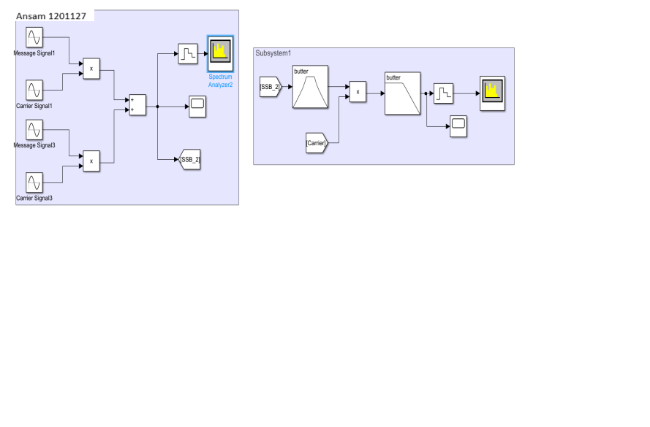

*Figure 20: SSBSC Demodulation Method 2(Lower Side) Block* Time domain representation of demodulation method 2 of SSBSC :

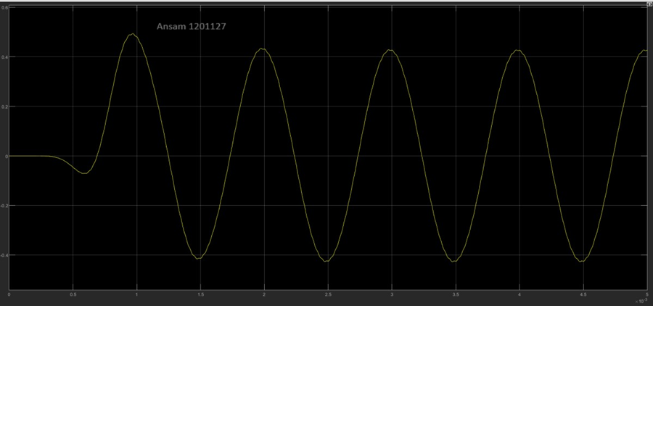

*Figure 21: Time domain demodulation of SSBSC method 2*

As shown the message signal returned but with some noise because the low pass filter is not ideal.

And the frequency domain representation method 2 of SSBSC :

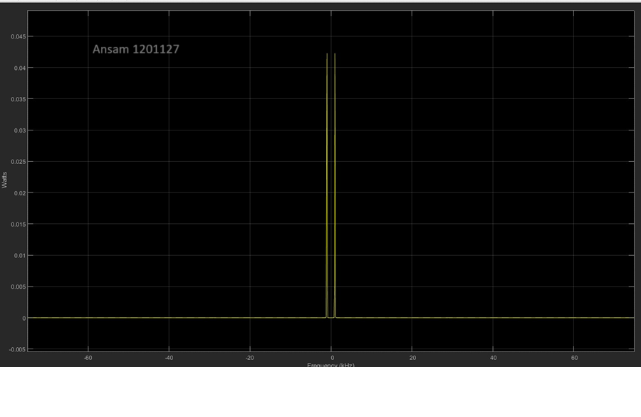

*Figure 22:Frequency domain demodulation of SSBSC method 2*

# ➢ All block diagram :

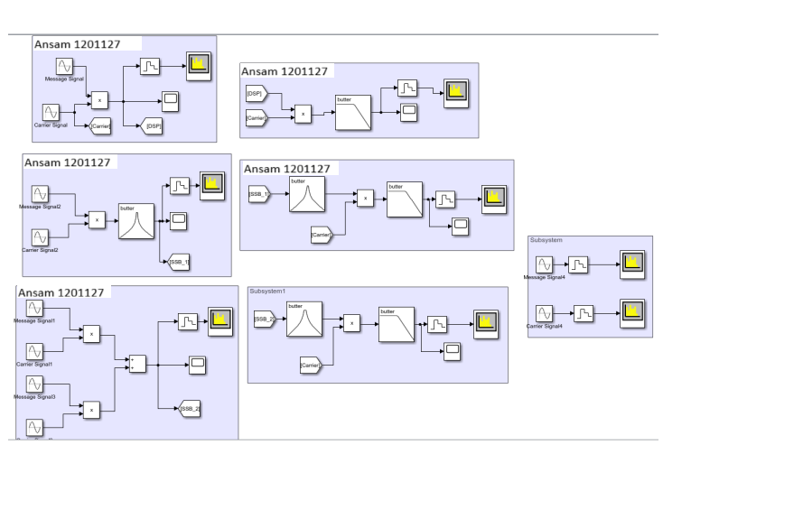

*Figure 23:All block diagram*